Admission Arrangments 2024/2025

- Introduction
- Magna Learning Partnership is the admission authority and responsible for the admission arrangements of The Trafalgar School at Downton. This document sets out the admission arrangements of The Trafalgar School for the academic year 2024/2025.

- The published admission number (PAN) for entry into the School is 150. The School will admit up to the PAN in the normal year of entry which is Year 7. Where there are more applications for admission than places available at the School, then places will be offered in accordance with the oversubscription criteria at Section 3 of this Policy.

- Where a child has an education, health and care plan (EHCP) which names the School, then that child will be admitted to the School and the number of available places in the PAN will reduce correspondingly.

- When applying to start school in Year 7 in September 2024 you must apply to your home Local Authority (“LA”). All applications for admission must be received by your home LA by the closing date of 31 October 2023. The home LA will make a single offer of a place on 1 March 2024 (or next working day). Parents will be able to make an online application at www.wiltshire.gov.uk. If an online application has been submitted, a written application is not necessary. The online facility will be available from 1 September 2023 up until the deadline of 31 October 2023.

- Religious Character of the School
The School does not have a religious character.

- Oversubscription Criteria
Where the School is oversubscribed (there are more applicants than places available) places will be allocated in accordance with the following criteria and in the following order. Please read the explanatory notes for further guidance.

- Looked After Children or Previously Looked After Children
A ‘looked after child’ or a child who was previously looked after but immediately after being looked became subject to an adoption, child arrangement, or special guardianship order including those who appear (to Magna Learning Partnership) to have been in state care outside of England and ceased to be in state care as a result of being adopted. A looked after child is a child who is (a) in the care of a local authority, or (b) being provided with accommodation by a local authority in the exercise of their social services functions (see the definition in Section 22(1) of the Children Act 1989). Proof will be required and must be submitted by the deadline date.

- Vulnerable Children
Children from families registered with the National Asylum Support Service; children or families with a serious medical, physical or psychological condition where written evidence is provided at the time of application from a senior clinical medical officer, general practitioner or specialist showing that it would be detrimental to the child or family not to be admitted to the preferred school. For the purpose of the criteria the word 'family' is determined as living at the same address at the time of the application and also living at the same address on a permanent basis. Proof will be required and must be submitted by the deadline date.

- Children living in the Catchment Area with a sibling at the School
A child living inside the Catchment Area is eligible for this category where they have a sibling attending the School on the date of application and the sibling will still be attending the School at the time of admission.

- Children living in the Catchment Area

- Children living outside the Catchment Area with a sibling at the School
A child living outside the Catchment Area is eligible for this category where they have a sibling attending the School on the date of application and the sibling will still be attending the School at the time of admission.

- Children of Staff at the School
Children of all staff employed at the school for two or more years at the time at which the application to the school is made and/or the member of staff is recruited to fill a vacant post for which there is a demonstrable skill shortage.

- All other children

Tie Breaker
If there are not enough places to satisfy all the applications under any one criterion, priority will be given to those living nearest the School. The School will adopt the measurement system of Wiltshire Local Authority to determine the distance from the School to the Home address. Where two or more applicants live an equal distance from the School and it is not possible to differentiate between them, priority will be determined by random allocation through the drawing of lots supervised by someone independent of the School.
Oversubscription Criteria: Explanatory Notes

Catchment Area means the geographical area from which children will be afforded priority for admission to the School. A map indicating the Catchment Area is detailed below. A larger map is available to view on the School website. A hard copy is available at the School office.

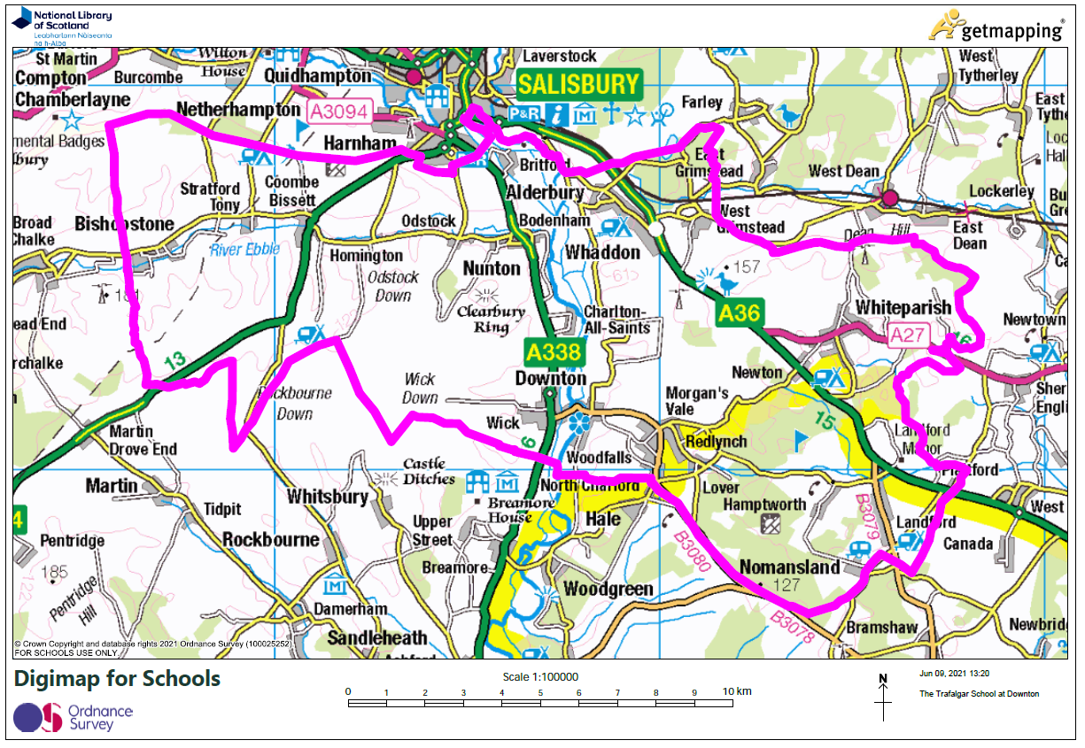

Vulnerable Children
- Medical need means where written evidence has been provided from a senior clinical medical officer or the child’s general practitioner / specialist showing that the child’s condition would make it detrimental to the child’s health not to admit him/her to the School. This may include written evidence where the parent has a medical need and/or disability which would make it detrimental for the child to attend a different school. Evidence to be relied upon must be submitted to the School on or before 31 October 2023.
- Social Need means where the child is of confirmed refugee status. Written evidence of this status from the home LA must be submitted to the School on or before 31 October 2023.

Sibling means brother or sister, half brother or sister, adopted brother or sister, step brother or sister, foster brother or sister, or the child of the parent/carer’s partner where the child for whom admission is sought is living in the same family unit as that sibling and at the same address.

Home address means the place where the child resides for the majority of the school week (Sunday to Thursday) with the person/s who legally has care of the child (child care arrangements are excluded). The School may require documentary evidence of house ownership or tenancy together with evidence of the child’s residency at the property.
- Supplementary Information Form (SIF)
The School does not use a SIF.

- Appeals
- Where an application is unsuccessful the parents/carers have the statutory right to bring an appeal against that decision to an independent appeal panel. Details of how to appeal will be included in the letter advising that the application has been unsuccessful.

- The admission appeal timetable is published on the School’s website by 28 February each year.

- Important Information
- Admission of children outside their normal age group
Parents may seek a place for their child outside their normal age group, for example if the child is gifted and talented or has experienced problems such as ill health.

Such requests should be discussed with the Headteacher as early as possible in the admissions process. This will allow the School sufficient time to make a decision regarding the request before the closing date for applications and national offer day. Decisions to admit a pupil outside their normal age group will be based on the circumstances of each case and based on what is in the best interests of the child concerned. We may request supporting professional evidence to assist in the decision-making. There is no legal requirement for this medical or educational evidence to be secured from an appropriate professional. However, failure to provide this may impede our ability to make an informed decision.

- Multiple Birth Applications
Where there are multiple birth applications the PAN will be exceeded or increased provided it is practicable at the point of allocation in order to ensure that multiple birth siblings can be allocated places at the School.

- Waiting Lists
If the School is oversubscribed for September 2024 entry a waiting list will be maintained until 31 December 2024. The position of the child on the waiting list will correspond with the oversubscription criteria; it will not be based on length of time on the waiting list. The right of appeal at Section 5 remains. You may request your child’s name be removed from the waiting list at any time. If a place is offered but refused then the child’s name will be removed from the waiting list.

- Withdrawal of an Offer
The School may withdraw an offer in certain circumstances, for example where it has been offered in error, has been made on the basis of a fraudulent or intentionally misleading application, or a parent has not responded to an offer of a place within a reasonable period of time.

- In Year Admissions
- Applications for in year admission may be submitted at any time during the school year. The application form is on the School website or a paper copy may be requested from the School office. All forms should be returned to the School.

- Where the School has no spaces available, because the admission of another child would prejudice the efficient education of others at the School or would prejudice the efficient use of resources, the application will be refused and a right of appeal, as set out in Section 5, will arise.

- The oversubscription criteria at Section 3 will be only used where the School is considering more than one in year application at the same time and there are not enough spaces to accept all applicants.

- Further Information
- Important information published by the LA applies to some aspects of school admissions. If you are considering applying for a place at the School you are advised to refer to your home LA’s website.

- If you have any questions in relation to these admission arrangements please contact the School office:

Admissions Officer
The Trafalgar School
Breamore Road
Downton
Salisbury
SP5 3HN

Telephone: 01725 550300

Email: admin@trafalgar.wilts.sch.uk

- The School will handle all personal data in accordance with the requirements of the Data Protection Act 2018.

